
The Islamia University of Bahawalpur

Project Title
Online Doctor Appointment Booking

A project presented to
Department of Computer Science, IUB Bahawalpur

In partial fulfillment
of the requirement for the degree of

Bachelor of Science in Computer Science (2021-2025)

By
MOHAMMAD ARSLAN

Student Name
MOHAMMAD ARSLAN
Roll No F21BDOCS1M01164
Session 2021-2025

DECLARATION
We hereby declare that this software, neither whole nor as a part has been copied out from any source. It is further declared that we have developed this software and accompanied report entirely on the basis of our personal efforts. If any part of this project is proved to be copied out from any source or found to be reproduction of some other. We will stand by the consequences. No Portion of the work presented has been submitted of any application for any other degree or qualification of this or any other university or institute oflearning.

Student Name : MOHAMMAD ARSLAN

CERTIFICATE OF APPROVAL

It is to certify that the final year project of BS (CS) “Project title” was developedby
STUDENT NAME ,Roll No, SESSIONunder the supervision of “SUPERVISOR NAME” and that in (his/her) opinion; it is fully adequate, in scope and quality for the degree of Bachelors of Science in Computer Sciences.

Supervisor

-----------------------------------

External Examiner

------------------------------------

Chairman Department of Computer Science

-----------------------------------

Acknowledgement

Give acknowledgment to all who helped to complete this project.

Mohammad Arslan

-----------------------------

Abbreviations

Provide a list of all abbreviation used in the document.

SRS | Software Require Specification
PC | Personal Computer

Table of Contents
1 Introduction 1
1.1 Brief 1
1.2 Relevance to Course Modules 1
1.3 Project Background 1
1.4 Related Material and Literature 1
1.5 Analysis from Literature Review (in the context of your project) 1
1.6 Methodology and Software Lifecycle for This Project 1
1.6.1 Rationale behind Selected Methodology 1
2 Problem Definition 2
2.1 Problem Statement 2
2.2 Deliverables and Development Requirements 2
2.3 Current System 2
Figure 2.1: Sample picture 2
3 Requirement Analysis 3
3.1 Use Cases Diagram 3
3.2 Functional Requirements 3
3.3 Non-Functional Requirements 3
4 Design and Architecture 4
4.1 System Architecture 4
4.2 Data Representation [Diagram + Description] 4
4.3 Process Flow/Representation 4
5 Implementation 5
5.1 Algorithm 5
5.2 External APIs 5
5.3 User Interface 5
6 Testing and Evaluation 6
6.1 Manual Testing 6
6.1.1 System testing 6
6.1.2 Unit Testing 6
6.1.3 Functional Testing 7
6.1.4 Integration Testing 7
6.2 Automated Testing: 8
7 Conclusion and Future Work 9
7.1 Conclusion 9
7.2 Future Work 9

Introduction
The Software Design Document describes the specifications for the Doctor Appointment Website, designed to facilitate seamless interaction between patients and doctors. This website aims to provide users with an easy-to-use interface for booking appointments, maintaining medical records, and communicating with healthcare providers.

1.1 Brief
This project titled “Online Doctor Appointment Website” is a web-based application developed using the MERN Stack—MongoDB, Express.js, React.js, and Node.js. The main objective of the system is to facilitate users in booking appointments with available doctors in a streamlined manner, eliminating the need for manual hospital visits and queues. The system supports three roles: User, Doctor, and Admin. Each role comes with its own dashboard and features, such as doctor management, appointment booking, profile updates, and data analytics.
JWT-based authentication ensures secure login and signup processes. The frontend is developed using React.js and allows real-time updates and user interactivity. The backend leverages Express.js and Node.js to handle API logic and database interactions with MongoDB. Images are stored using Cloudinary API.
The entire project follows the Agile methodology, allowing iterative development and integration of user feedback. Each chapter in this report explains different aspects of the development process, from planning to implementation and testing.

1.2 Relevance to Course Modules
This project integrates knowledge from multiple core BSCS courses, including:
- Web Application Development – for React, Node.js, and MongoDB integration.
- Software Engineering – to follow SDLC models and structured design.
- Database Systems – to design and manage MongoDB schemas for Doctors, Users, and Appointments.
- Human-Computer Interaction – to design intuitive user interfaces for different stakeholders.
- Computer Networks and Security – for secure authentication using JWT.

1.3 Project Background
The increasing burden on healthcare systems and the need for digitization has led to a demand for online appointment solutions. In many developing regions, patients face challenges in booking timely appointments with medical professionals due to manual and inefficient systems. This project aims to provide a centralized digital platform where patients can connect with doctors and book appointments based on availability and specialization.
The application bridges the communication gap between patients and healthcare providers. It not only facilitates users but also helps doctors manage their appointments effectively.

1.4 Related Material and Literature
Several similar platforms exist, such as Practo, ZocDoc, and Oladoc. These platforms support appointment booking and telemedicine features. However, most of them are commercial products with limited accessibility or are region-specific.
Research also suggests the increasing importance of cloud-based healthcare systems. The use of React.js for building responsive interfaces and MongoDB for flexible document storage is commonly recommended in the literature for such dynamic platforms.

1.5 Analysis from Literature Review (in the context of your project)
Compared to existing literature and systems, this project provides a simplified, open-source, and role-based web solution tailored for academic and small clinic use. Unlike large-scale platforms, this project also includes a dedicated Admin panel and Doctor dashboard with real-time availability management and analytics, which is often missing in smaller or template-based systems.
The system’s modular architecture makes it scalable, maintainable, and extendable for features such as teleconsultation or prescription generation in the future.

1.6 Methodology and Software Lifecycle for This Project
This project uses the Agile Software Development Lifecycle, emphasizing iterative development, collaboration, and continuous testing. The main stages followed were:
- Requirement Gathering
- System Design
- Incremental Development
- Unit and Integration Testing
- User Feedback and Refinement
- Deployment and Documentation

1.6.1 Rationale behind Selected Methodology
Agile methodology was selected due to its flexibility and adaptability in academic environments. It allowed the team to focus on delivering core modules first and then adding advanced features like admin and doctor dashboards. Frequent testing and feedback cycles helped refine the system for better usability.

Problem Definition
This chapter outlines the problem the project intends to solve, the deliverables, and an overview of any current system if applicable.

2.1 Problem Statement
In traditional hospital and clinic environments, booking an appointment often involves physically visiting the healthcare facility or making a phone call, which can result in long waiting times, scheduling conflicts, and inefficient appointment management. This approach not only wastes valuable time but can also lead to missed or delayed healthcare services.
The absence of a centralized digital platform for managing appointments poses challenges for both patients and healthcare professionals. Patients struggle to find available doctors, and doctors face difficulties in managing appointments efficiently. Moreover, without a reliable digital system, it is hard to track the history of patients, reschedule appointments, or manage user profiles securely.
This project addresses the problem by creating a full-stack, web-based Online Doctor Appointment System where users (patients) can easily search for doctors, view their profiles, book appointments, manage their schedules, and get instant updates — all from one centralized platform. Doctors and admins can manage their respective operations through dedicated dashboards.

2.2 Deliverables and Development Requirements
The following are the primary deliverables of the project:
- A responsive frontend web application developed using React.js.
- A secure backend REST API developed using Node.js and Express.js.
- A MongoDB database schema for storing users, doctors, and appointments.
- Integration with Cloudinary for image storage.
- JWT-based authentication and authorization for users, doctors, and admins.
- Three dashboards:
  - User Dashboard: View/edit profile, manage appointments.
  - Doctor Dashboard: View patients, accept/reject appointments, manage schedule.
  - Admin Dashboard: Manage users, doctors, appointments.
Development Requirements:
Requirement Type | Description
Software | Node.js, React.js, MongoDB, Express.js, Cloudinary API
Tools | Visual Studio Code, Postman, MongoDB Compass
Language | JavaScript (Frontend & Backend)
Database | MongoDB
Other | Git for version control, JWT for authentication

2.3 Current System
Currently, there is no digital appointment system implemented in most small or mid-sized clinics, especially in local or rural regions. Appointment scheduling, if done at all, is mostly manual and leads to the following issues:
- No centralized doctor directory
- No real-time availability checking
- Time-consuming manual booking
- Lack of appointment history for patients
- No automation in reminders, confirmations, or cancellations
By introducing this system, the above-mentioned gaps are filled with automation, centralization, and role-based control.

Current Manual Appointment Process (PlainUML)

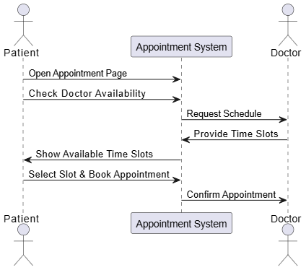

Figure 2.1 Manual System Diagram

Requirement Analysis
This chapter presents the software requirements gathered for the Online Doctor Appointment Website. It includes functional and non-functional requirements and a use case diagram that describes the user interactions within the system.

3.1 Use Case Diagram
This use case diagram presents the core functionalities of the Online Doctor Appointment System through three key roles. Patients can register/login, search doctors, book/cancel appointments, and manage profiles. Doctors handle appointment management, profile updates, and schedule modifications. Administrators oversee system operations including doctor management, appointment monitoring, and availability control, clearly defining each role's responsibilities within the platform.
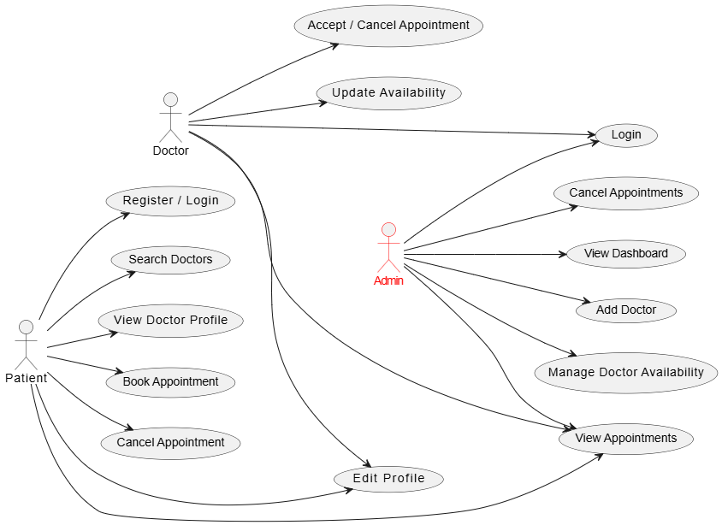

Figure 3.1 Use Case Diagram

3.2 Functional Requirement
FR-01: User Registration and Login
User Authentication and Authorization This feature enables patients to create accounts and securely log in using email and password. Authentication is managed through JWT tokens to ensure data security and session integrity. Role-based access control restricts users to functionalities relevant to their role (patient, doctor, or admin). Secure password hashing and token expiration mechanisms prevent unauthorized access.
Identifier | FR-01
Title | User Registration and Login
Requirement | Users can register and log in using email and password. JWT is used for secure authentication.
Source | User, Stakeholder
Rationale | Allows users to access personalized features securely.
Business Rule | Secure password storage and token-based authentication (e.g., JWT).
Dependencies | None
Priority | High

Table 3.1 User Registration and Login

FR-02: Doctor Registration and Login
Doctors undergo a registration process to join the platform, requiring admin approval for profile verification. They log in using credentials protected by JWT tokens to access dashboards for managing appointments and availability. Email verification ensures the legitimacy of doctor accounts. Secure authentication prevents unauthorized access to sensitive patient data.
Identifier | FR-02
Title | Doctor Registration and Login
Requirement | Doctors can register and access dashboards after authentication.
Source | Doctor, Admin
Rationale | Doctors need secure access to manage appointments.
Business Rule | Authentication must follow security standards (e.g., JWT, email verification).
Dependencies | None
Priority | High

Table 3.2 Doctor Registration and Login

FR-03: Admin Login
Administrators log in with enhanced security protocols, such as multi-factor authentication, to access system-wide controls. This restricted access ensures only authorized personnel manage doctor registrations, appointments, and platform settings. Audit logs track admin activities to maintain accountability. Security measures align with industry standards to protect sensitive operations.
Identifier | FR-03
Title | Admin Login
Requirement | Admin can log in to access administrative dashboards.
Source | Admin
Rationale | Ensures only authorized users manage sensitive data.
Business Rule | Multi-level authentication for admin credentials.
Dependencies | None
Priority | High

Table 3.3 Admin Login

FR-01: Search Doctors
Patients can search for doctors using filters like specialization, availability, fees, or location. Real-time updates ensure accuracy in displayed results, enhancing user experience. Search algorithms prioritize verified and highly-rated doctors. This feature reduces time spent finding suitable medical professionals.
Identifier | FR-04
Title | Search Doctors
Requirement | Users can search doctors by category/specialty.
Source | User
Rationale | Simplifies finding relevant doctors.
Business Rule | Results filtered by availability/specialization.
Dependencies | Doctor registration, availability
Priority | Medium

Table 3.4 Search Doctors

FR-05: View Doctors Profile
Detailed profiles display doctor qualifications, experience, fees, availability. Verified badges indicate authenticated profiles, ensuring credibility. Users can assess suitability before booking appointments. Dynamic UI elements like images and bios enhance user trust and engagement.
Identifier | FR-05
Title | View Doctor Profile
Requirement | Users can view doctor profiles (experience, fees, etc.).
Source | User
Rationale | Helps users make informed booking decisions.
Business Rule | Only verified profiles are displayed.
Dependencies | Doctor registration, profile data
Priority | Medium

Table 3.5 View Doctor Profile

FR-06: Book Appointment
Users select available time slots from a doctor’s schedule and confirm bookings with payment integration. Real-time checks prevent double-booking, and notifications confirm successful reservations. Doctors receive instant updates about new appointments. This feature streamlines the consultation scheduling process.
Identifier | FR-06
Title | Book Appointment
Requirement | Users can book available doctor slots.
Source | User, Doctor
Rationale | Facilitates consultations.
Business Rule | Prevent double bookings; confirm slot availability.
Dependencies | Doctor availability
Priority | High

Table 3.6 Book Appointment

FR-07: Cancel Appoointment
Users and doctors can cancel appointments up to 12 hours before the scheduled time, with automated refunds if applicable. Cancellation triggers notifications to all parties and updates slot availability. Policies ensure fairness and minimize last-minute disruptions. Audit trails record cancellation reasons for accountability.
Identifier | FR-07
Title | Cancel Appointment
Requirement | Users/doctors can cancel appointments.
Source | User, Doctor
Rationale | Provides scheduling flexibility.
Business Rule | Cancellation allowed before 12 hours prior.
Dependencies | Appointment booking
Priority | Medium

Table 3.7 Cancel Appointment

FR-08: Manage Profiles
Users update personal details (e.g., address, contact), while doctors modify availability, fees, and qualifications. Input validation ensures data accuracy, and admin approval is required for critical changes. Doctors can toggle availability status to control bookings. This feature maintains up-to-date user and doctor information.
Identifier | FR-08
Title | Manage Profiles
Requirement | Users/doctors can edit profiles and availability.
Source | User, Doctor
Rationale | Maintains accurate system data.
Business Rule | Validate input; verify specialization updates.
Dependencies | Login authentication
Priority | Medium

Table 3.8 Manage Profiles

FR-09: View Appointment
All roles access dashboards to view past and upcoming appointments sorted by date. Filters allow sorting by status (e.g., completed, canceled, pending). Patients track consultation history, while doctors monitor schedules. Admins oversee all appointments for platform management.
Identifier | FR-09
Title | View Appointments
Requirement | All roles can view appointments.
Source | User, Doctor, Admin
Rationale | Ensures transparency in scheduling.
Business Rule | Sort chronologically; filter by status.
Dependencies | Booking/cancellation systems
Priority | High

Table 3.9 View Appointment

FR-10: Logout
Users can securely log out by clicking the logout button, which clears token data and redirects them to the login page. This ensures that sessions are properly terminated to maintain security.

Identifier | FR-09
Title
  Logout
Requirement
  Users can securely log out of their accounts, and the system clears session data.
Source
  User
Rationale | Ensures data security and proper session management.
Business Rule | Sessions must be cleared completely upon logout.
Dependencies | FR-01
Priority
  High

Table 3.10 Logout

3.3 Non-Functional Requirements

1. Usability
- The platform must provide an intuitive and user-friendly interface for all users.
- Accessibility features must support users with visual, auditory, and motor disabilities (e.g., screen readers, keyboard navigation).

2. Performance
- The system should efficiently handle up to 500 concurrent users without noticeable latency.
- All web pages must load within 3 seconds on a standard 10 Mbps internet connection.

3. Security
- All user data must be encrypted during both transmission (HTTPS) and storage.
- Payment transactions must comply with PCI DSS (Payment Card Industry Data Security Standard) guidelines.

4. Reliability
- The system must maintain an uptime of 99.9% over any rolling 30-day period.
- Regular automated backups and restore mechanisms must ensure data recovery in case of system failure.

5. Scalability
- The architecture must support horizontal scaling to accommodate a growing number of users.
- It should allow easy integration of future modules or third-party services.

6. Maintainability
- The codebase must follow clean code practices for readability and modular structure.
- System updates and patches must be deployable with minimal or zero downtime.

7. Compatibility
- The platform must operate consistently across major web browsers: Chrome, Firefox, Edge, and Safari.
- It must be fully responsive, functioning correctly on mobile phones, tablets, and desktops.

Design and Architecture
This chapter discusses the high-level architecture of the Online Doctor Appointment Website, its data structures, and flow of operations among components and users.

4.1 System Architecture
The system follows a three-tier architecture consisting of:
- Frontend Layer: Built with React.js, this layer handles all user interactions and sends HTTP requests to the backend APIs.
- Backend Layer: Built with Node.js and Express.js, this layer processes logic, handles authentication, and communicates with the database.
- Database Layer: MongoDB stores the persistent data related to users, doctors, and appointments.

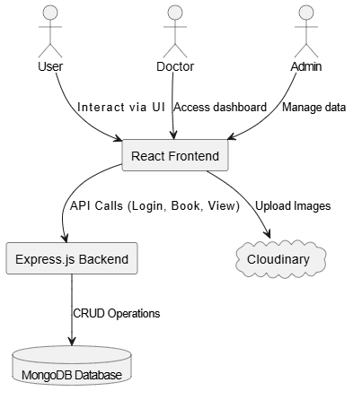

Figure 4.1 System Architecture Diagram

4.2 Data Representation
The system uses MongoDB collections to represent entities like User, Doctor, and Appointment. Each is stored as a document in a NoSQL format. Below are the main fields for each collection:

4.1 User Collection Schema
Field | Type | Description
_id | ObjectId | Unique user ID
name | String | Full name of the user
email | String | Unique user email
password | String | Hashed password
image | String | Cloudinary URL of profile image
dob | Date | Date of birth
gender | String | Gender of the user
address | Object | Address details (line1, line2)
phone | String | Contact number

Table 3.10 Logout

4.2: Doctor Collection Schema
Field | Type | Description
_id | ObjectId | Unique doctor ID
name | String | Doctor's full name
email | String | Doctor email
password | String | Hashed password
image | String | Profile image URL (Cloudinary)
speciality | String | Medical specialization
degree | String | Medical qualification
experience | String | Years of experience
about | String | Short biography
available | Boolean | Doctor’s availability
fees | Number | Appointment fee
address | Object | Address details
date | Timestamp | Creation timestamp
slots_booked | Object | Booked time slots

Table 3.10 Logout

4.3: Appointment Collection Schema

Field | Type | Description
_id | ObjectId | Unique ID
userId | ObjectId | Reference to user
docId | ObjectId | Reference to doctor
slotDate | String | Date of appointment
slotTime | String | Time of appointment
userData | Object | Embedded user snapshot
docData | Object | Embedded doctor snapshot
amount | Number | Appointment fee
cancelled | Boolean | Cancellation status
isCompleted | Boolean | Completion status
date | Timestamp | Booking timestamp

Table 3.10 Logout

4.3 Process Flow / Representation

The system's key processes are represented using Data Flow Diagrams (DFDs) to illustrate the interaction between users, the application, and the database

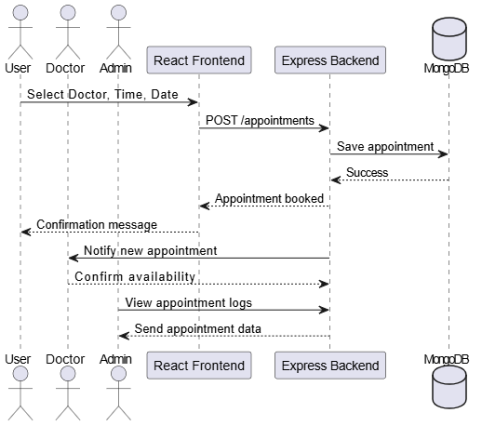

Figure 4.3 Process Flow Diagram

4.4 Design Models
In this system, the Model-View-Controller (MVC) pattern is followed:
- Model: Represents MongoDB schemas and database operations.
- View: Represented by the React components that render data.
- Controller: Handles routing and logic in Express.js.
Each controller function is modularized (e.g., bookAppointment, getDoctors, cancelAppointment) and connects to a model which performs the database operations.

Class Diagram
The class diagram represents the system's structure, showing the classes, attributes, methods, and relationships among objects.
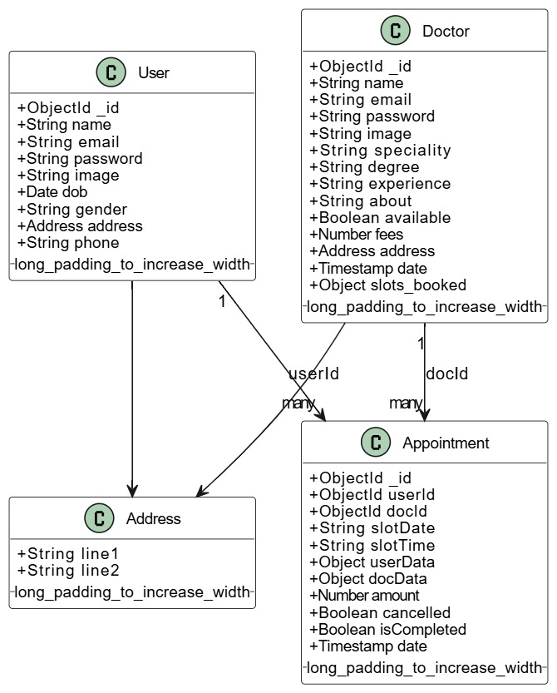

Figure 4.4 Class Diagram

5 Implementation
This chapter outlines the detailed implementation of the Online Doctor Appointment System, including core algorithms, integrated APIs, and the user interface design. It provides an overview of how the backend APIs are structured and connected with the frontend interface.

5.1 Algorithm
The application uses logical control flow rather than complex algorithms. Below is a natural language description of key operations.

User Login and Registration

POST /register → Check if email already exists
If not → Hash password → Save user → Return token
POST /login → Validate credentials
If valid → Generate JWT token → Return success

Booking an Appointment

POST /book-appointment
→ Check if selected slot exists in Doctor's booked slots
If not → Create slot and book it
If already exists → Return "Slot Already Booked"
→ Save appointment in DB with user & doctor info

Doctor Availability

Admin sends POST /change-availability with doctorId
→ Find doctor → Toggle availability → Save to DB

5.2 External APIs
The following APIs have been integrated into the system, grouped by functionality and role.

User APIs
Endpoint | Method | Description | Middleware
/register | POST | Register a new user | -
/login | POST | Login user and return JWT token | -
/get-profile | GET | Fetch logged-in user's profile | authUser
/update-profile | POST | Update user profile (image upload supported) | authUser, multer
/book-appointment | POST | Book an appointment with a doctor | authUser
/appointments | GET | List user's appointments | authUser
/cancel-appointments | POST | Cancel a user appointment | authUser

User Apis Table 5.1

Doctor APIs
Endpoint | Method | Description | Middleware
/list | GET | List all doctors | -
/login | POST | Doctor login | -
/appointments | GET | View appointments for the doctor | authDoctor
/appointment-complete | POST | Mark appointment as completed | authDoctor
/appointment-cancel | POST | Cancel doctor appointment | authDoctor
/dashBoard | GET | Doctor dashboard analytics | authDoctor
/profile | GET | Get doctor profile | authDoctor
/update-profile | POST | Update doctor profile and availability | authDoctor

Doctor Apis Table 5.2

Admin APIs
Endpoint | Method | Description | Middleware
/login | POST | Admin login | -
/add-doctor | POST | Add new doctor (with image upload) | authAdmin, multer
/all-doctor | GET | View all doctors | authAdmin
/change-availability | POST | Change doctor availability status | authAdmin
/appointments | GET | View all appointments | authAdmin
/cancel-appointment | POST | Cancel an appointment from admin panel | authAdmin
/admin-dashboard | GET | View overall stats (users, doctors, appointments) | authAdmin

Admin Apis Table 5.3

5.3 User Interface
The frontend, built using React.js, is structured using modular components and route-based access. It adapts dynamically depending on the logged-in user’s role (User, Doctor, Admin).

Home Page

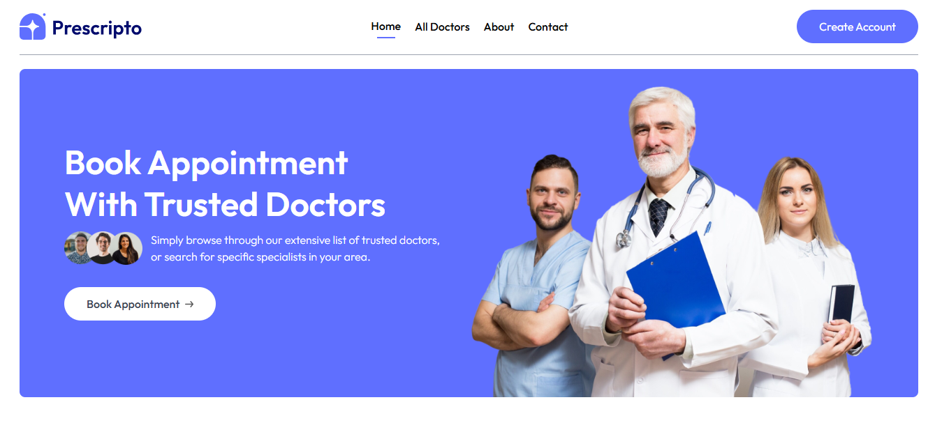

Figure 5.1

All Doctors Page

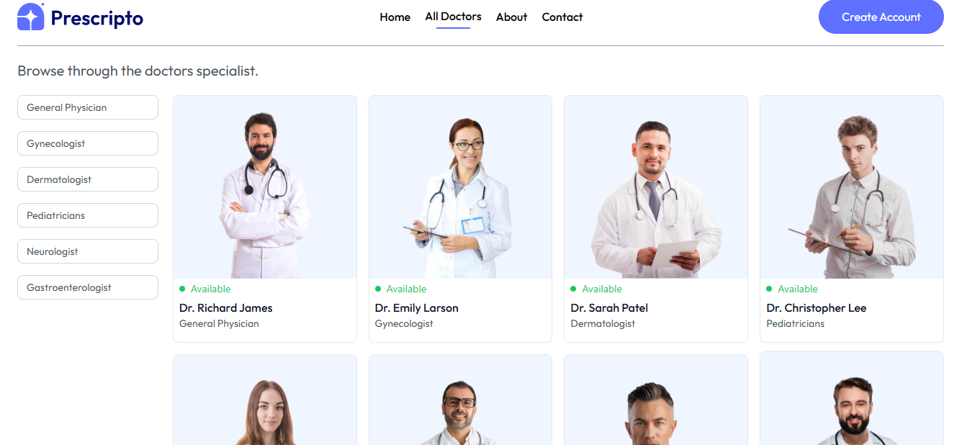

Figure 5.2

About Page

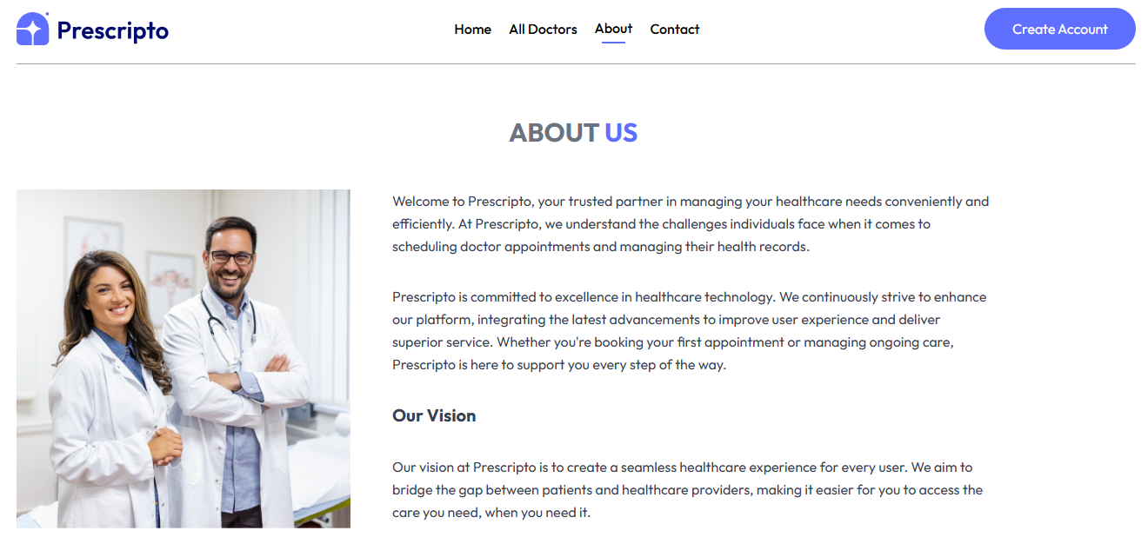

Figure 5.3

Appointment Booking Page

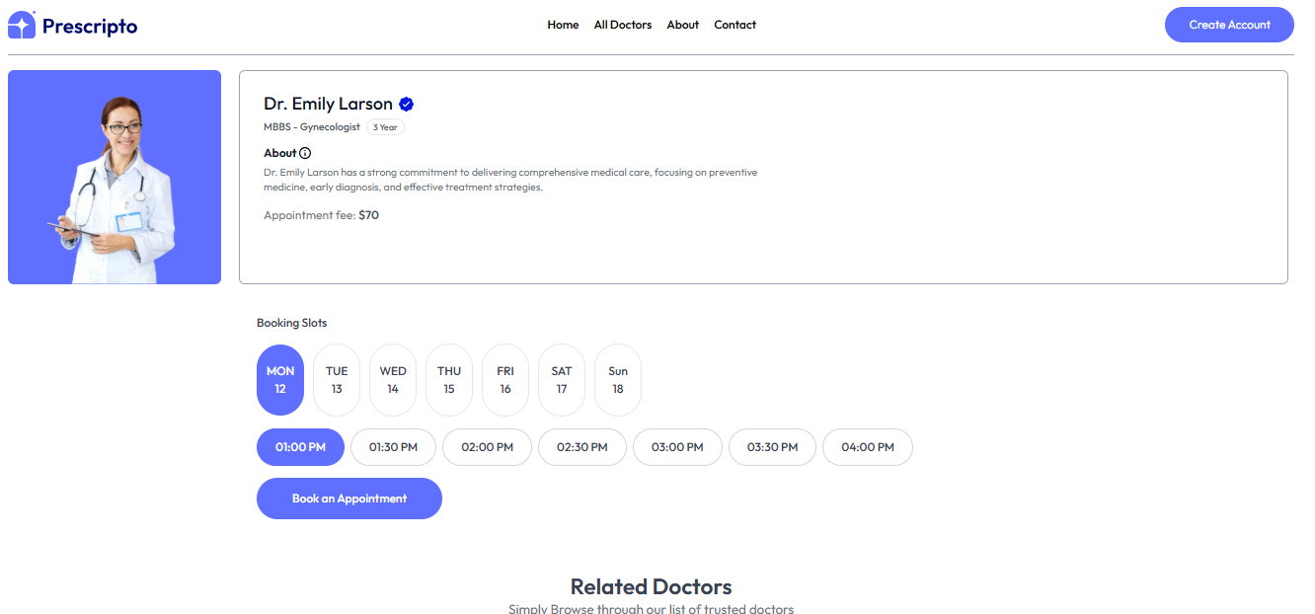

Figure 5.4

My Appointment Page

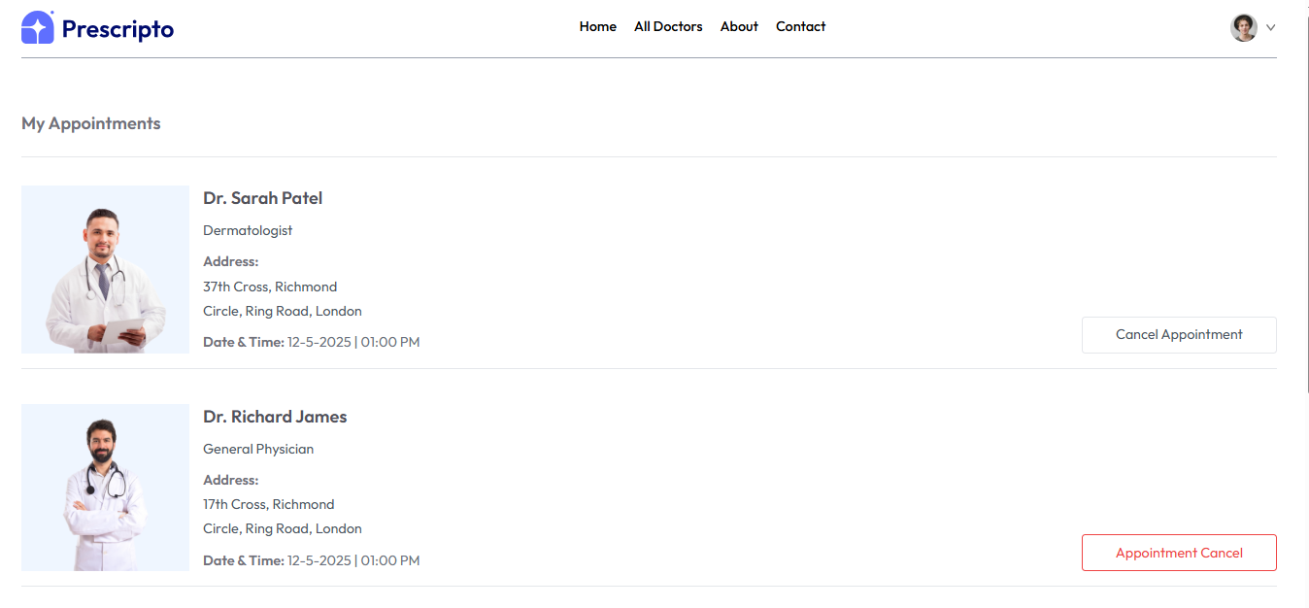

Figure 5.5

Doctor Dashbaord

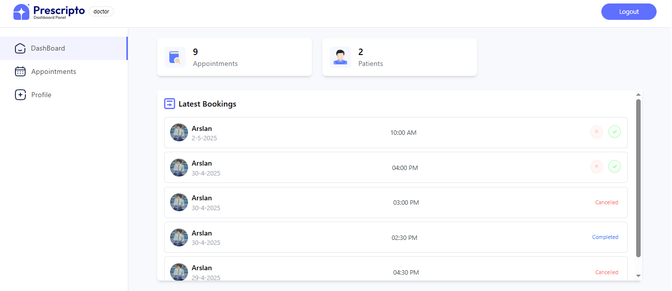

Figure 5.6

Doctor Appointments Page

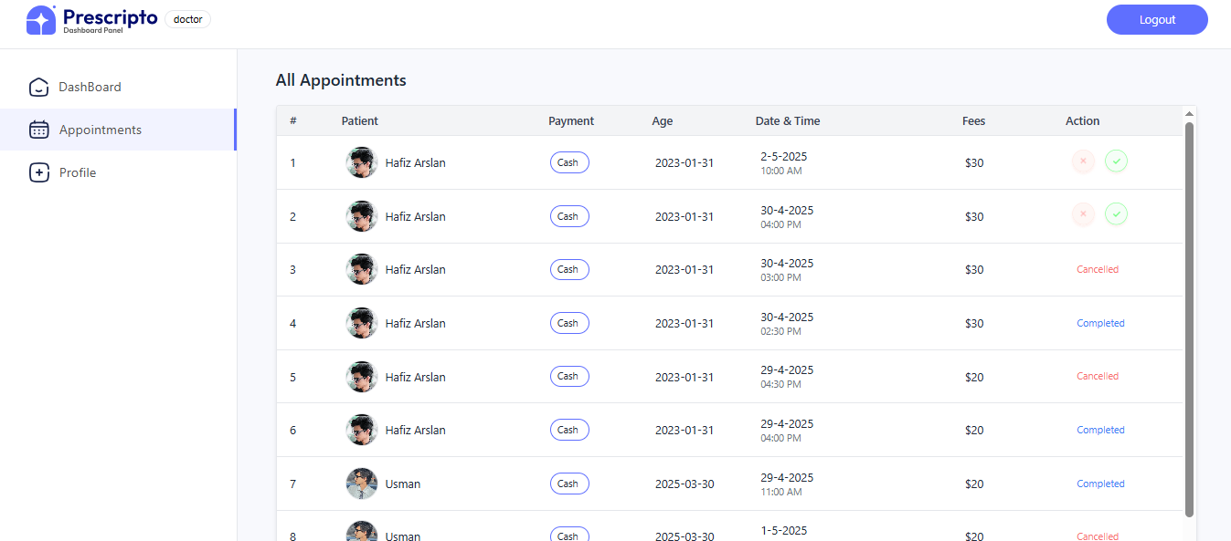

Figure 5.7

Admin Dashboard

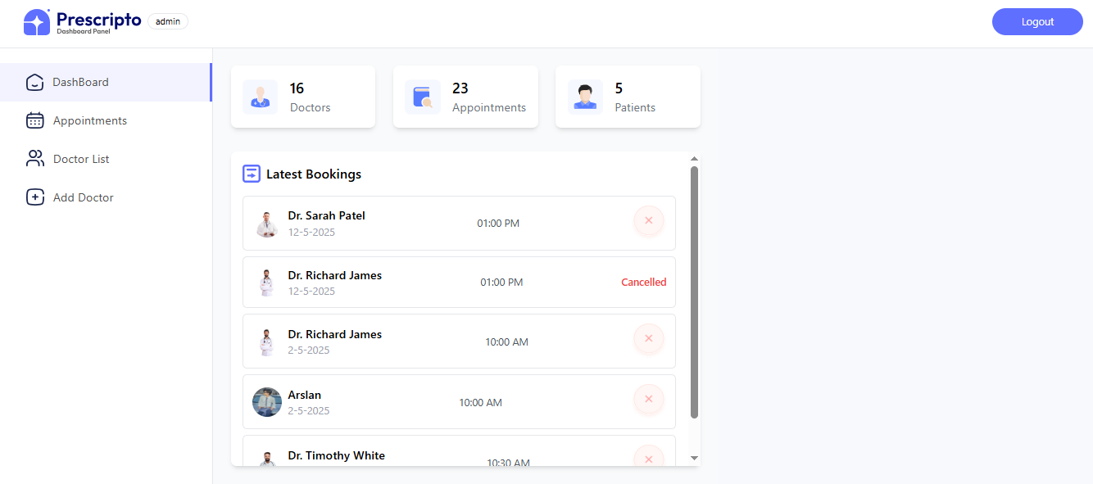

Figure 5.8

Admin Appointment Page

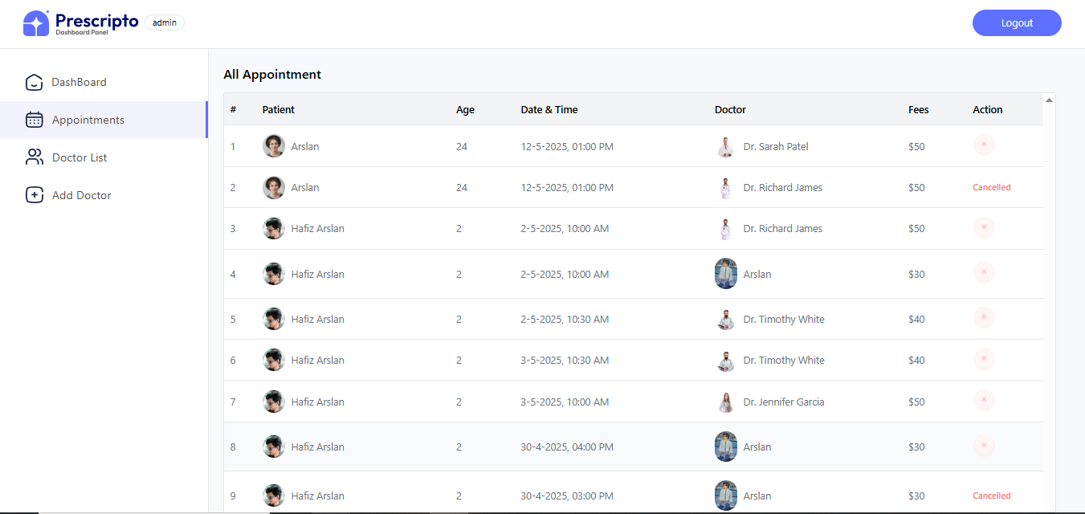

Figure 5.9

6:Testing and Evaluation
This chapter presents the testing strategies adopted to ensure the Online Doctor Appointment System functions correctly. Both manual and automated testing approaches were employed to validate functionality, performance, and system reliability.

6.1 Manual Testing
Manual testing was performed on key modules to validate functionality, role-based access, data flow, and appointment operations.

6.1.1 System Testing
System testing verifies the overall application’s functionality from end to end. It ensures components work correctly together and deliver the expected output.
No. | Test Case | Attribute & Value | Expected Result | Result
1 | Register as New User | Email: ali@gmail.com, Password: 12345678 | New user registered and redirected to login page | Pass
2 | Login as Doctor | Email: doctor@gmail.com, Password: 12345678 | Dashboard loaded with doctor appointments | Pass
3 | Book Appointment | Select Doctor, Date: 29-04-2025, Time: 10 AM | Appointment booked successfully | Pass
4 | Admin View All Doctors | Admin Login → Doctor List | All doctors with availability toggle displayed | Pass
5 | Cancel Appointment as User | User Profile → My Appointments → Cancel | Appointment marked as cancelled | Pass

Table 6.1 System Testing

6.1.2 Unit Testing
Each feature was individually tested to ensure correct performance in isolation.

Unit Testing 1: User Login
No. | Test Script | Attribute & Value | Expected Result | Result
1 | Enter valid credentials | Email: user1@gmail.com, Password: 123 | Redirect to home page | Pass
2 | Enter invalid password | Email: user1@gmail.com, Password: abc | Error message: Invalid credentials | Pass

Table 6.2 Unit Testing 1

Unit Testing 2: Doctor Profile Update
No. | Test Script | Attribute & Value | Expected Result | Result
1 | Update fees and address | Fees: 150, Address: Lahore | Profile updated successfully | Pass
2 | Submit without required fields | Fees: -, Address: - | Error message: Required fields | Pass

Table 6.3 Unit Testing 2

6.1.3 Functional Testing
Functional testing ensures each system function works as expected under various user roles.

Functional Testing 1: Booking and Viewing Appointments
No. | Test Case | Attribute & Value | Expected Result | Result
1 | Book appointment with doctor | Doctor: Dr. A, Date: 01-05-2025, Time: 9 AM | Appointment appears in My Appointments | Pass
2 | Cancel booked appointment | Cancel button in My Appointments | Appointment status updated to cancelled | Pass

Table 6.4 Functional Testing

Functional Testing 2: Admin Operations
No. | Test Case | Attribute & Value | Expected Result | Result
1 | Add new doctor | Name: Dr. Z, Speciality: Eye | Doctor added with confirmation | Pass
2 | Toggle doctor availability | Toggle off for Dr. A | Doctor availability set to false | Pass

Table 6.5 Functional Testing 2

6.1.4 Integration Testing
Integration testing ensures all modules work together as intended.
No. | Test Case | Attribute & Value | Expected Result | Result
1 | User login and book appointment | Login → Doctor List → Book Appointment | Successful booking, view in user & doctor panel | Pass
2 | Admin cancel appointment | Admin → Appointments → Cancel | Appointment marked cancelled for all parties | Pass
3 | Doctor completes appointment | Doctor → Mark Complete | Status updated to completed in all views | Pass

Table 6.6 Integration Testing

6.2 Automated Testing
Basic automated testing was applied to API endpoints using Postman for regression testing and response validation.

Tools Used:
Tool Name | Description | Applied On | Results
Postman | API request testing | Login, Profile, Booking, Cancellation APIs | All passed
JWT.io | Token decoder/validator | Token generation for all roles | Valid tokens
MongoDB Compass | DB status validation | Check inserted appointment/user data | Consistent

Table 6.7 Automated Testing

7: Conclusion and Future Work
This chapter summarizes the achievements of the project and highlights opportunities for further enhancement.

7.1 Conclusion
The Online Doctor Appointment Website developed using the MERN Stack successfully fulfills its goal of streamlining the doctor-patient appointment process in a digital environment. The project delivers a complete role-based solution with secure authentication and seamless user interaction for Users, Doctors, and Admins.
Key outcomes of the project include:
- User Functionality: Patients can register, search for doctors by category, view profiles, book and cancel appointments, and manage personal profiles—all from a user-friendly dashboard.
- Doctor Functionality: Doctors can access their appointment lists, update their availability and profile details, and manage appointment status through a dedicated dashboard.
- Admin Control: The admin has full control over doctor management, appointment records, and dashboard analytics, ensuring smooth system supervision.
- Security: JWT-based authentication ensures secure login for all three roles.
- Performance: The system demonstrates stable performance and reliability, with responsive design and accurate data tracking.
Overall, the project provides a complete, scalable, and maintainable foundation for digital health appointment management.

7.2 Future Work
While the system is fully functional, several enhancements can be implemented in future versions:
- Online Payment Integration
Implement a payment gateway (e.g., Stripe, PayPal) for appointment fee payments at the time of booking.
- Teleconsultation Feature
Add secure video consultation capabilities using WebRTC or third-party services like Zoom SDK or Agora.
- Prescription Module
Allow doctors to upload digital prescriptions that can be downloaded or emailed to patients.
- Notifications and Reminders
Integrate SMS or email APIs to notify users about upcoming appointments and status updates.
- Role Expansion
Add support for additional roles such as receptionists, nurses, or lab technicians for hospital-specific implementations.
- Health Record Management
Allow patients and doctors to maintain and view medical history including previous diagnoses and prescriptions.
- Mobile App Development
Create mobile apps (Android/iOS) using React Native or Flutter for enhanced user accessibility and real-time engagement.

